
Project Name: AI CHATBOT WEB APPLICATION
Internship Domain: Python with Gen AI
Submitted By: KANURI NAVYANJALI
Submitted To: Think Champ Pvt Ltd

INTERNSHIP MINI PROJECT REPORT

Table of Contents
S.No | Topic | Page No
1 | Introduction
2 | History of Project
3 | Requirements
4 | Objective
5 | Source Code
6 | Output Screenshots
7 | Conclusion

Introduction
The AI Chatbot Web Application is a simple web-based chatbot developed using Python, Flask, HTML, CSS, and JSON. The application allows users to interact with a chatbot through a browser-based interface. Users can enter messages, and the chatbot responds automatically based on predefined responses stored in the system.
The project demonstrates the integration of frontend and backend technologies. HTML and CSS are used to create an attractive user interface, while Flask handles the communication between the user and the chatbot. JSON is used to store chatbot responses, making the system easy to manage and update.
This project helps in understanding web application development, chatbot functionality, and frontend-backend integration. It also provides practical experience in building interactive applications using Python and modern web technologies.

History of Project
The concept of chatbots originated to enable computers to communicate with humans through text-based conversations. Early chatbots used simple rule-based systems to respond to user queries, while modern chatbots use Artificial Intelligence and Machine Learning to understand and generate human-like responses.
Over the years, chatbot technology has become increasingly popular and is now used in customer support, education, healthcare, banking, and many other industries. Popular virtual assistants such as Siri, Alexa, and ChatGPT have demonstrated the importance of conversational AI in everyday life.
This project is a basic implementation of a chatbot system developed for learning purposes. It uses predefined responses and Flask-based communication to simulate a real chatbot environment, helping students understand the fundamentals of chatbot development and web application design.

Requirements
Software Requirements:
Operating System: Windows 10/11
Programming Language: Python 3.x
Framework: Flask
Frontend: HTML, CSS
Code Editor: Visual Studio Code
Browser: Google Chrome / Edge

Hardware Requirements:
Processor: Intel i3 or above
RAM: 4 GB or above
Storage: 500 MB free space
Internet Connection: Required for installation

Objective
The main objective of this project is to develop a simple AI Chatbot that can communicate with users through a web interface.
Objectives:
- Accept user messages
- Generate chatbot responses
- Provide an interactive user experience
- Connect frontend and backend using Flask
- Understand basic chatbot development concepts

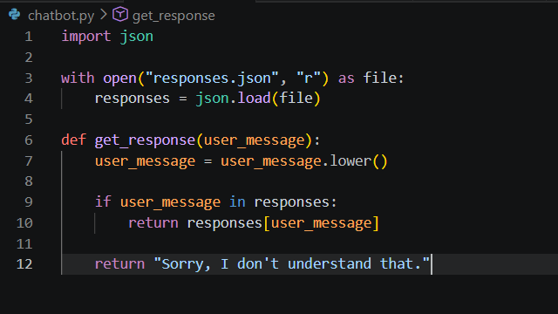
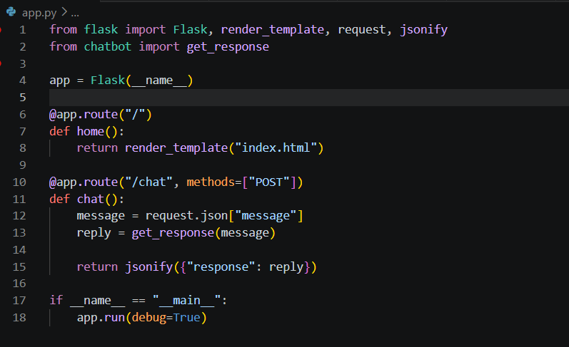
Source Code
app.py chatbot.py
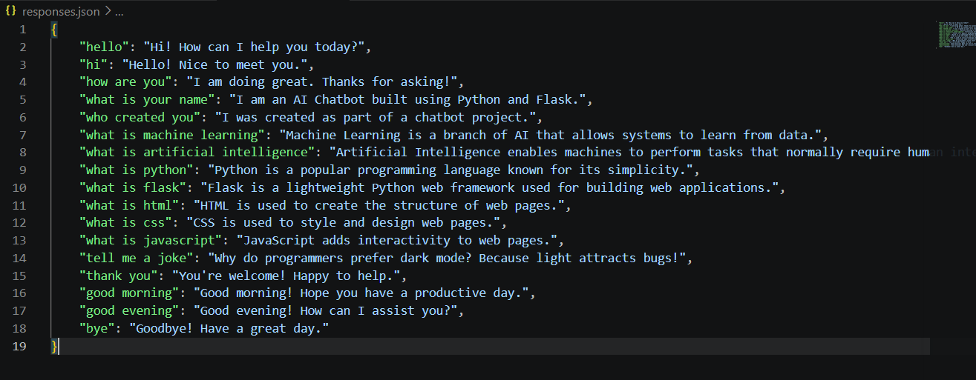
responses.json

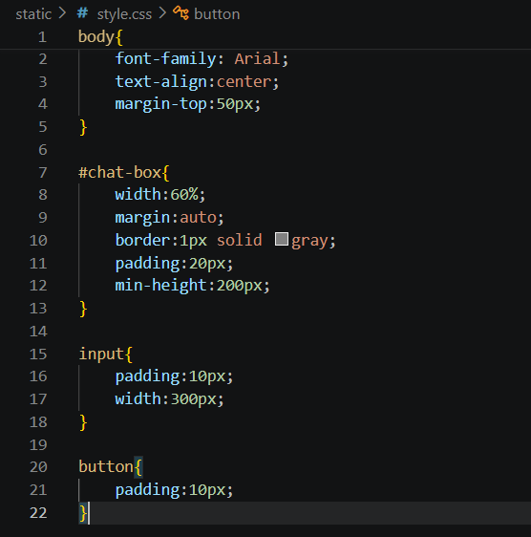
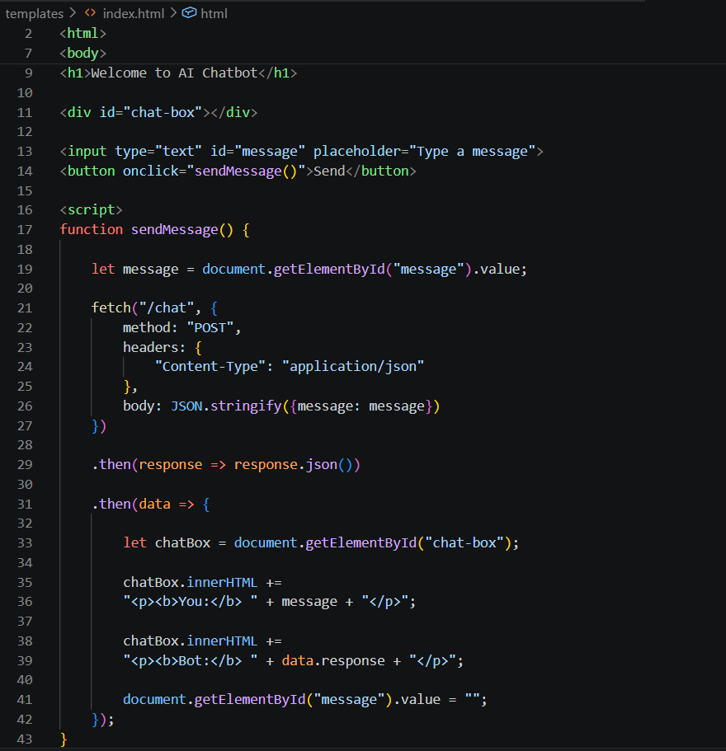
index.html style.css
Output Screenshots

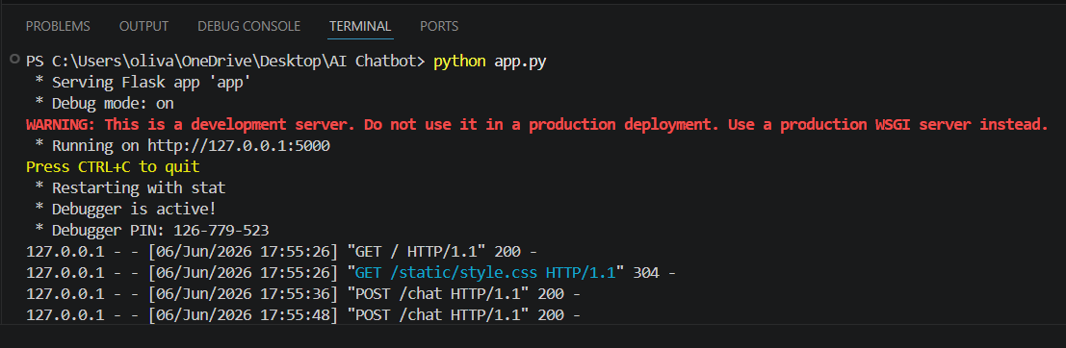

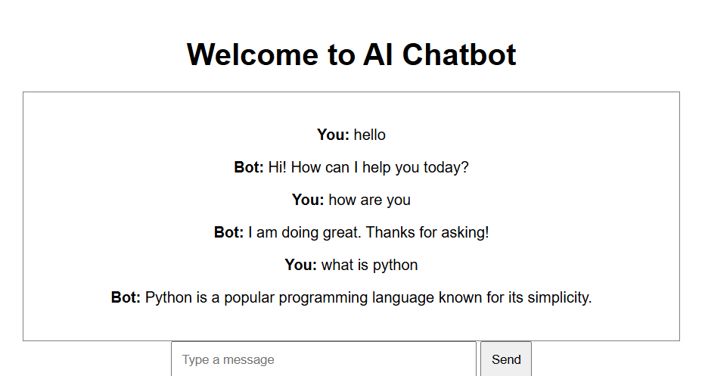

Conclusion
The AI Chatbot Web Application was successfully developed using Python, Flask, HTML, CSS, and JSON. The chatbot can accept user input and generate appropriate responses through a web interface.
This project helped in understanding chatbot development, frontend-backend integration, and web application deployment concepts. It also improved problem-solving and programming skills.

